**Week 4 Ex-2 Output**

**1. GET Request: Retrieve All Books**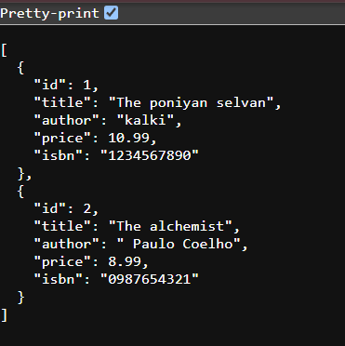

2.**POST Request: Create a New Book**

**3. PUT Request: Update an Existing Book by ID**



**4. DELETE Request: Delete a Book by ID  
**